Crating model in spring boot

1. Create folders name it Models inside main and java project.
2. Create file with extension of java
3. Input the all field in code
4. 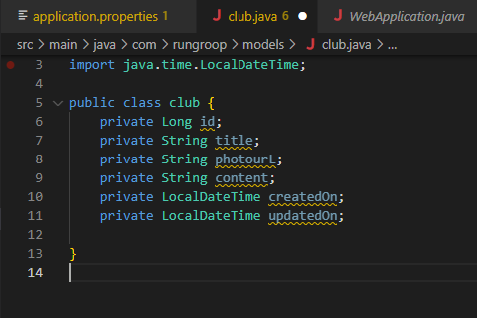
5. To view another command pres alt+enter

